

COMPUTER PROJECT

BASED ON PYTHON PROGRAMMING LANGUAGE
ON THE TOPIC:
“CAB RESERVATION SYSTEM”

PRESENTED BY:
NAME-
REGISTRATION NO-

CONTENTS
a) Acknowledgement
b) Introduction to Python
c) Introduction to the project
d) Python source code
e) Output screens
f) Conclusion
g) Hardware and software requirements
h) Bibliography

CERTIFICATE

This to certify that DHARMENDRA SINGH of std. Diploma in Computer Science Engineering has completed the computer project on ‘CAB RESERVATION System’ under the guidance of his computer teacher Mr.Ankit kumar Sinha.

………………………. ………………………. Signature of Internal Signature of External

……………………………..
Signature of Principal

ACKNOWLEDGEMENT

I would like to express a deep sense of thanks and gratitude to our Principal, Mr. Kameshwar Singh, for her co-ordination in extending every possible support for the completion of this project and a sincere thanks to our computer teacher Mr.Ankit Sinha for guiding me immensely through the course of my project. His constructive advice and constant motivation have been responsible for the successful completion of my project.

My sincere thanks to my parents for their motivation and support. I must thank my group mates for their timely help and support for completion of this project.

INTRODUCTION TO PYTHON
Python is developed by Guido van Rossum. Guido van Rossum started implementing Python in 1989. Python is a very simple programming language so even if you are new to programming, you can learn python without facing any issues.
FEATURES OF PYTHON PROGRAMMING :
1. Readable: Python is a very readable language.
2. Easy to Learn: Learning python is easy as this is a expressive and high level programming language, which means it is easy to understand the language and thus easy to learn.
3. Cross platform: Python is available and can run on various operating systems such as Mac, Windows, Linux, UNIX etc. This makes it a cross platform and portable language.
4. Open Source: Python is an open source programming language.
5. Large standard library: Python comes with a large standard library that has some handy codes and functions which we can use while writing code in Python.
6. Supports exception handling: If you are new, you may wonder what is an exception? An exception is an event that can occur during program exception and can disrupt the normal flow of program. Python supports exception handling which means we can write less error prone code and can test various scenarios that can cause an exception later on.
INTRODUCTION TO THE PROJECT
This project aims to provide software to car rental servicing centre that maintains the information about the customer details,vehicle details,insurance details,booking details and transaction details of the customer.

HOPE YOU’LL ENJOY IT …!
SOURCE CODE
"""***************************************
MODULES USED IN THE PROJECT
***************************************"""
import mysql.connector as co
from tabulate import tabulate
import pickle
import os
from datetime import date
import datetime
"""***************************************
FUNCTION TO GENERATE CAB ID
***************************************"""

def gen_cid():
try:
inFile=open("cab.txt","r+")
n=inFile.read()
n=int(n)
n+=1
inFile.close()
infile=open("cab.txt",'w')
infile.write(str(n))
infile.close()
#this will generate cab id for each CAB
return(n)
except IOError:
print("I/O error occured")
"""*********************************
Function to Add CAB
*********************************"""

def add_cab():
try:
mycon=co.connect(host="localhost",user="root",password="jssp",database="CAB_BOOKING")
cursor=mycon.cursor()
cid=gen_cid()
regno=input("\n\nEnter registration number: ")
cab_type=input("\nEnter type of the CAB: ")
cab_desc=input('Enter cab description : ')
nos=int(input('Enter no. of seats : '))
owner=input("Enter Owner's Name: ")
driver=input("Enter driver's Name: ")
ownadd=input('Enter owner address: ')
mob=int(input('Enter Mobile no. : '))
query="insert into CAB_MASTER values ("+str(cid)+",'"+regno+"','"+cab_type+"','"+cab_desc+"',"+str(nos)+",'"+owner+"','"+driver+"','"+ownadd+"',"+str(mob)+")"
#print(query)
cursor.execute(query)
mycon.commit()
mycon.close()
cursor.close()
print ("\n Cab added Successfully")
print ("\n\n YOUR CAB ID IS: ",cid)
print('Record has been saved in CAB_MASTER table')
except:
print('error in add_cab')

"""*************************************************
FUNCTION TO DISPLAY ALL CABS
*************************************************"""

def show_all_cab():
try:
mycon=co.connect(host="localhost",user="root",password="jssp",database="CAB_BOOKING")
cursor=mycon.cursor()
strQry="select * from cab_master"
cursor.execute(strQry)
data = cursor.fetchall()
if data == []:
print("No records found")
else:
print("")
h=["CAB ID","REG NO.","CAB TYPE","CAB DESC","NO OF SEATS","OWNER NAME","DRIVER NAME","OWNER ADDRESS","MOB NO"]
#print(tabulate(data,headers=h,tablefmt='fancy_grid'))
#print(tabulate(data,headers=h,tablefmt='textile'))
print(tabulate(data,headers=h))
mycon.close()
cursor.close()
except:
print('error')

"""************************************************
FUNCTION TO SEARCH CAB
************************************************"""
def search_cab():
flag=0
try:
ano=int(input("Enter cab ID : "))
mycon=co.connect(host="localhost",user="root",password="jssp",database="CAB_BOOKING")
cursor=mycon.cursor()
strQry="select * from CAB_MASTER where cid="+str(ano)+""
cursor.execute(strQry)
data = cursor.fetchone()
if data == []:
print("cab ID does not exist")
else:
print("cab ID :",data[0])
print("registration no. :",data[1])
print("Cab type :",data[2])
print("Cab Description :",data[3])
print("no. of seats :",data[4])
print("owner name :",data[5])
print("driver name:",data[6])
print("owner address:",data[7])
print("mobile no. :",data[8])
mycon.close()
cursor.close()
except :
print('error ')

"""*****************************************
FUNCTION TO MODIFY RECORD
*****************************************"""

def modify_cab():
print("1:Edit Registration number ")
print("2:Edit Cab Type")
print("3:Edit Cab Description")
print("4:Edit Number Of Seat")
print("5:Edit Owner's Name")
print("6:Edit Driver's Name")
print("7:Edit Owner's Address")
print("8:Edit Mobile Number")
print("9:Return")
print("\t\t-------------------------------------------------")
choice=int(input("enter your choice"))
if choice==1:
edit_regno()
elif choice==2:
edit_Ctype()
elif choice==3:
edit_Cdesc()
elif choice==4:
edit_nos()
elif choice==5:
edit_owner()
elif choice==6:
edit_driver()
elif choice==7:
edit_ownadd()
elif choice==8:
edit_mob()
elif choice==9:
return
else:
print("Error:invalid choice try again.....")
conti="press any key to return to main menu"

def edit_regno():
try:
mycon=co.connect(host="localhost",user="root",password="jssp",database="CAB_BOOKING")
cursor=mycon.cursor()
cabid=int(input('Enter cab id'))
q="select * from cab_master where cid="+str(cabid)+""
cursor.execute(q)
data = cursor.fetchall()
if data==[]:
print("No record found")
else:
h=["CAB ID","REGISTRATION NO.","CAB TYPE","CAB DESCRIPTION","NUMBER OF SEATS","OWNER'S NAME","DRIVER'S NAME","OWNER'S ADDRESS","MOBILE NUMBER"]
print(tabulate(data,headers=h))
nm=input("enter new registration no.")
st="update cab_master set regno='%s' where cid='%s'"%(nm,cabid)
cursor.execute(st)
mycon.commit()
mycon.close()
cursor.close()
print('data updated successfully')
except :
print('error ')

def edit_Ctype():
try:
mycon=co.connect(host="localhost",user="root",password="jssp",database="CAB_BOOKING")
cursor=mycon.cursor()
cabid=int(input('Enter cab id: '))
q="select * from cab_master where cid="+str(cabid)+""
cursor.execute(q)
data = cursor.fetchall()
if data==[]:
print("No record found")
else:
h=["CAB ID","REGISTRATION NO.","CAB TYPE","CAB DESCRIPTION","NUMBER OF SEATS","OWNER'S NAME","DRIVER'S NAME","OWNER'S ADDRESS","MOBILE NUMBER"]
print(tabulate(data,headers=h))
nm=input("enter new cab type: ")
st="update cab_master set cab_type='%s' where cid='%s'"%(nm,cabid)
cursor.execute(st)
mycon.commit()
mycon.close()
cursor.close()
print('data updated successfully')
except :
print('error ')

def edit_Cdesc():
try:
mycon=co.connect(host="localhost",user="root",password="jssp",database="CAB_BOOKING")
cursor=mycon.cursor()
cabid=int(inpput('Enter cab id'))
q="select * from cab_master where cid="+str(cabid)+""
cursor.execute(q)
data = cursor.fetchall()
if data==[]:
print("No record found")
else:
h=["CAB ID","REGISTRATION NO.","CAB TYPE","CAB DESCRIPTION","NUMBER OF SEATS","OWNER'S NAME","DRIVER'S NAME","OWNER'S ADDRESS","MOBILE NUMBER"]
print(tabulate(data,headers=h))
nm=input("enter new cab description: ")
st="update cab_master set cab_desc='%s' where cid='%s'"%(nm,cabid)
cursor.execute(st)
mycon.commit()
mycon.close()
cursor.close()
print('data updated successfully')
except :
print('error ')

def edit_nos():
try:
mycon=co.connect(host="localhost",user="root",password="jssp",database="CAB_BOOKING")
cursor=mycon.cursor()
cabid=int(input('Enter cab id'))
q="select * from cab_master where cid="+str(cabid)+""
cursor.execute(q)
data = cursor.fetchall()
if data==[]:
print("No record found")
else:
h=["CAB ID","REGISTRATION NO.","CAB TYPE","CAB DESCRIPTION","NUMBER OF SEATS","OWNER'S NAME","DRIVER'S NAME","OWNER'S ADDRESS","MOBILE NUMBER"]
print(tabulate(data,headers=h))
nm=int(input("enter new no. of seats: "))
st="update cab_master set nos='%s' where cid='%s'"%(nm,cabid)
cursor.execute(st)
mycon.commit()
mycon.close()
cursor.close()
print('data updated successfully')
except :
print('error ')

def edit_owner():
try:
mycon=co.connect(host="localhost",user="root",password="jssp",database="CAB_BOOKING")
cursor=mycon.cursor()
cabid=int(input('Enter cab id'))
q="select * from cab_master where cid="+str(cabid)+""
cursor.execute(q)
data = cursor.fetchall()
if data==[]:
print("No record found")
else:
h=["CAB ID","REGISTRATION NO.","CAB TYPE","CAB DESCRIPTION","NUMBER OF SEATS","OWNER'S NAME","DRIVER'S NAME","OWNER'S ADDRESS","MOBILE NUMBER"]
print(tabulate(data,headers=h))
nm=input("enter new owner's name: ")
st="update cab_master set owner='%s' where cid='%s'"%(nm,cabid)
cursor.execute(st)
mycon.commit()
mycon.close()
cursor.close()
print('data updated successfully')
except :
print('error ')

def edit_driver():
try:
mycon=co.connect(host="localhost",user="root",password="jssp",database="CAB_BOOKING")
cursor=mycon.cursor()
cabid=int(input('Enter cab id'))
q="select * from cab_master where cid="+str(cabid)+""
cursor.execute(q)
data = cursor.fetchall()
if data==[]:
print("No record found")
else:
h=["CAB ID","REGISTRATION NO.","CAB TYPE","CAB DESCRIPTION","NUMBER OF SEATS","OWNER'S NAME","DRIVER'S NAME","OWNER'S ADDRESS","MOBILE NUMBER"]
print(tabulate(data,headers=h))
nm=input("enter new driver's name")
st="update cab_master set driver='%s' where cid='%s'"%(nm,cabid)
cursor.execute(st)
mycon.commit()
mycon.close()
cursor.close()
print('data updated successfully')
except :
print('error ')
def edit_ownadd():
try:
mycon=co.connect(host="localhost",user="root",password="jssp",database="CAB_BOOKING")
cursor=mycon.cursor()
cabid=int(input('Enter cab id'))
q="select * from cab_master where cid="+str(cabid)+""
cursor.execute(q)
data = cursor.fetchall()
if data==[]:
print("No record found")
else:
h=["CAB ID","REGISTRATION NO.","CAB TYPE","CAB DESCRIPTION","NUMBER OF SEATS","OWNER'S NAME","DRIVER'S NAME","OWNER'S ADDRESS","MOBILE NUMBER"]
print(tabulate(data,headers=h))
nm=input("enter new owner's address")
st="update cab_master set ownadd='%s' where cid='%s'"%(nm,cabid)
cursor.execute(st)
mycon.commit()
mycon.close()
cursor.close()
print('data updated successfully')
except :
print('error ')

def edit_mob():
try:
mycon=co.connect(host="localhost",user="root",password="jssp",database="CAB_BOOKING")
cursor=mycon.cursor()
cabid=int(input('Enter cab id'))
q="select * from cab_master where cid="+str(cabid)+""
cursor.execute(q)
data = cursor.fetchall()
if data==[]:
print("No record found")
else:
h=["CAB ID","REGISTRATION NO.","CAB TYPE","CAB DESCRIPTION","NUMBER OF SEATS","OWNER'S NAME","DRIVER'S NAME","OWNER'S ADDRESS","MOBILE NUMBER"]
print(tabulate(data,headers=h))
nm=int(input("enter new mobile no. : "))
st="update cab_master set mob='%s' where cid='%s'"%(nm,cabid)
cursor.execute(st)
mycon.commit()
mycon.close()
cursor.close()
print('data updated successfully')
except :
print('error ')

"""***************************************
FUNCTION TO DELETE CAB
***************************************"""

def delete_cab(n):
try:
mycon=co.connect(host="localhost",user="root",password="jssp",database="CAB_BOOKING")
cursor=mycon.cursor()
q="select * from CAB_MASTER where cid="+str(n)+""
cursor.execute(q)
data = cursor.fetchall()
if data==[]:
print("No record found")
else:
h=["CAB ID","REGISTRATION NO.","CAB TYPE","CAB DESCRIPTION","NUMBER OF SEATS","OWNER'S NAME","DRIVER'S NAME","OWNER'S ADDRESS","MOBILE NUMBER"]
print(tabulate(data,headers=h))
c=input("Are you sure want to delete the account (Y/N) : ")
if c=='Y' or c=='y':
st="delete from CAB_MASTER where cid="+str(n)+""
cursor.execute(st)
mycon.commit()
print('CAB Deleted successfully')
mycon.close()
cursor.close()

except :
print('error')

"""***************************************
FUNCTION TO GENERATE booking ID
***************************************"""

def gen_bid():
try:
inFile=open("book.txt","r+")
n=inFile.read()
n=int(n)
n+=1
inFile.close()
infile=open("book.txt",'w')
infile.write(str(n))
infile.close()
#this will generate book id for each booking
return(n)
except IOError:
print("I/O error occured")
"""*********************************
Function to Add booking
*********************************"""

def add_booking():
try:
mycon=co.connect(host="localhost",user="root",password="jssp",database="CAB_BOOKING")
cursor=mycon.cursor()
today=date.today()
print("Date : ",today)
print("*"*50)
cid=int(input("Enter cab ID : "))
q="select * from CAB_MASTER where cid="+str(cid)
cursor.execute(q)
data = cursor.fetchall()
if data==[]:
print("No record found")
else:
h=["CAB ID","REG. NO.","CAB TYPE","DESCRIPTION","SEATS","OWNER'S NAME","DRIVER'S NAME","ADDRESS","MOB. NUMBER"]
print(tabulate(data,headers=h))
bid=gen_bid()
print(bid)
cnm=input("Enter customer's Name: ")
mob=input('Enter Mobile no. : ')
source=input('Enter pickup location : ')
dest=input('Enter drop location : ')
amt=float(input("Enter Bill Amount : "))
query="insert into BOOKINGS values ("
query+=str(bid)+","+str(cid)+",'"+cnm+"','"+mob+"','"+source+"','"+dest+"',"+str(amt)+")"
print(query)
cursor.execute(query)
mycon.commit()
print ("\n Cab booked Successfully")
print ("\n\n YOUR booking ID IS: ",bid)
print('Record has been saved in bookings table')
mycon.close()
cursor.close()
except:
print('error in booking')
print( "Booking Unsuccessful")

"""***************************************
FUNCTION TO DELETE booking
***************************************"""
def cancel_booking(n):
try:
mycon=co.connect(host="localhost",user="root",password="jssp",database="CAB_BOOKING")
cursor=mycon.cursor()
q="select * from bookings where bid="+str(n)+""
cursor.execute(q)
data = cursor.fetchall()
if data==[]:
print("No record found")
else:
h=["BOOKING ID","CAB ID","CUSTOMER NAME","MOB NO.","PICKUP LOCATION","DROP LOCATION"]
print(tabulate(data,headers=h))
c=input("Are you sure want to delete the account (Y/N) : ")
if c=='Y' or c=='y':
st="delete from BOOKINGS where bid="+str(n)+""
cursor.execute(st)
mycon.commit()
print('Booking Cancelled successfully')
mycon.close()
cursor.close()

except :
print('error')

"""*************************************************
FUNCTION TO DISPLAY ALL bookings
*************************************************"""

def show_all_bookings():
try:
mycon=co.connect(host="localhost",user="root",password="jssp",database="CAB_BOOKING")
cursor=mycon.cursor()
strQry="select * from bookings"
cursor.execute(strQry)
data = cursor.fetchall()
if data == []:
print("No records found")
else:
print("")
h=["BOOKING ID","CAB ID","CUSTOMER NAME","MOB NO.","PICKUP LOCATION","DROP LOCATION","Bill"]
#print(tabulate(data,headers=h,tablefmt='fancy_grid'))
#print(tabulate(data,headers=h,tablefmt='textile'))
print(tabulate(data,headers=h))
mycon.close()
cursor.close()
except:
print('error')
#**************************************************
# FUNCTION TO GENERATE BILL
#***************************************************

def bill_generate(n):
try:
mycon=co.connect(host="localhost",user="root",password="jssp",database="CAB_BOOKING")
cursor=mycon.cursor()
q="select * from Bookings where BID="+str(n)
cursor.execute(q)
data = cursor.fetchone()
if data==None:
print("No record found")
print( "\n\n Booking number not exist")
else:
print("...............................................")
print("\nBILL DETAILS\n")
print("...............................................")
print("Booking Id :",data[0])
print("Cab Id :",data[1])
print("Customer Name :",data[2])
print("Mob number :",data[3])
print("Pickup Location :",data[4])
print("Destination Location :",data[5])
print("You must pay :",data[6])
print("***********************************************")
print(".............END OF Bill.................")
print("***********************************************")
mycon.close()
cursor.close()
except:
print( "\n\n Booking Id not exist")
print( "Error in bill_generate function")

"""****************************************************************************
INTRODUCTORY FUNCTION
*****************************************************************************"""

def intro():
print ("CAB BOOKING SYSTEM")
print ("PRESENTED BY : SAKSHI PRIYA")
print ("SCHOOL : JUSCO SCHOOL SOUTH PARK")
print ("CLASS : 12-B")

#**************************************************************
# CAB MENU FUNCTION
#***********************************************************"""
def cab_menu():
while True:
print (60*"=")
print ("CAB MENU")
print ("1. Add New Cab")
print ("2. Modify Existing Cab")
print ("3. Delete Cab")
print ("4. View All Cab")
print ("5. Search Cab")
print ("6. Exit")
try:
ch=int(input("Enter Your Choice(1~6): "))
if ch==1:
add_cab()

elif ch==2:
modify_cab()

elif ch==3:
n=int(input("Enter CAB ID : "))
delete_cab(n)

elif ch==4:
show_all_cab()

elif ch==5:
search_cab()

elif ch==6:
break

else:
print("Input correct choice...(1-6)")

except NameError:
print ("Input correct choice...(1-6)")
#"""""""***************************************************************************
#THE MAIN FUNCTION OF PROGRAM
#*****************************************************************************""""""

intro()
while True:
print(50*"=")
print( "\tMAIN MENU:")
print(50*"=")
print( "1. Cab Master Menu")
print( "2. Cab Booking")
print( "3. Cancel Booking")
print( "4. Show All Booking")
print( "5. Search Booking")
print( "6. Exit")
try:
ch=int(input("Enter Your Choice(1~7): "))
if ch==1:
cab_menu()
elif ch==2:
add_booking()
elif ch==3:
cancel_booking()
elif ch==4:
show_all_bookings()
elif ch==5:
num=int(input("\n\nEnter Booking Number: "))
bill_generate(num)
elif ch==6:
break
else:
print( "Input correcr choice...(1-7)")
except NameError:
print( "Input correct choice...(1-7)")

#*******************************************************************

raw_input("\n\n\n\n\nTHANK YOU\n\nPress any key to exit...")

"""*************************************************************
END OF THE PROJECT
*************************************************************"""

OUTPUT SCREENS
OUTPUT SCREEN 1
(WELCOME & MAIN MENU)
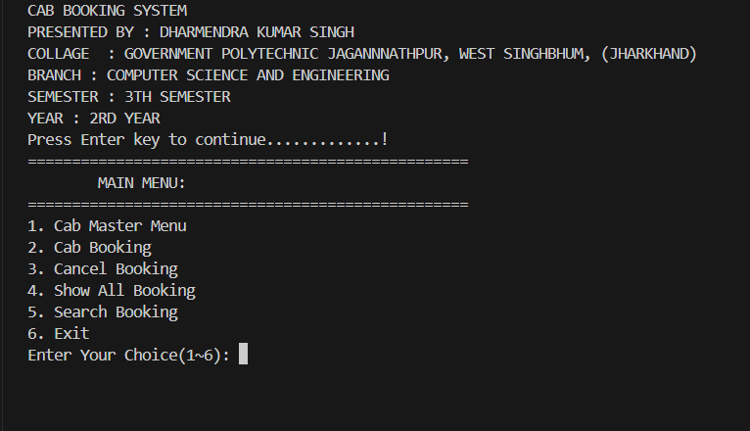

OUTPUT SCREEN 2
(CAB MENU OF PROGRAM)
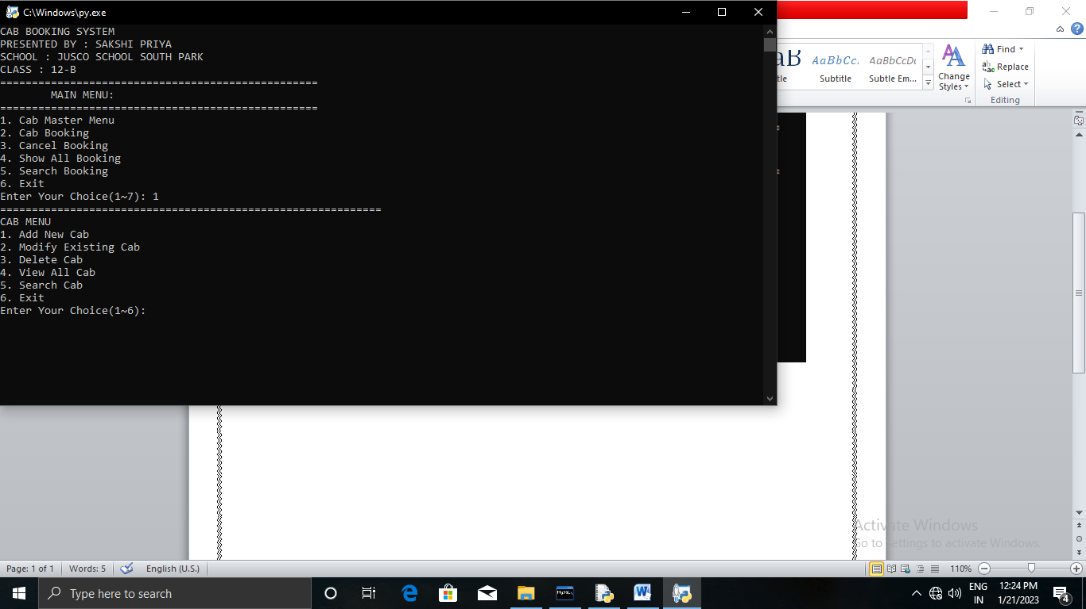
OUTPUT SCREEN 3
(ADD NEW CAB)
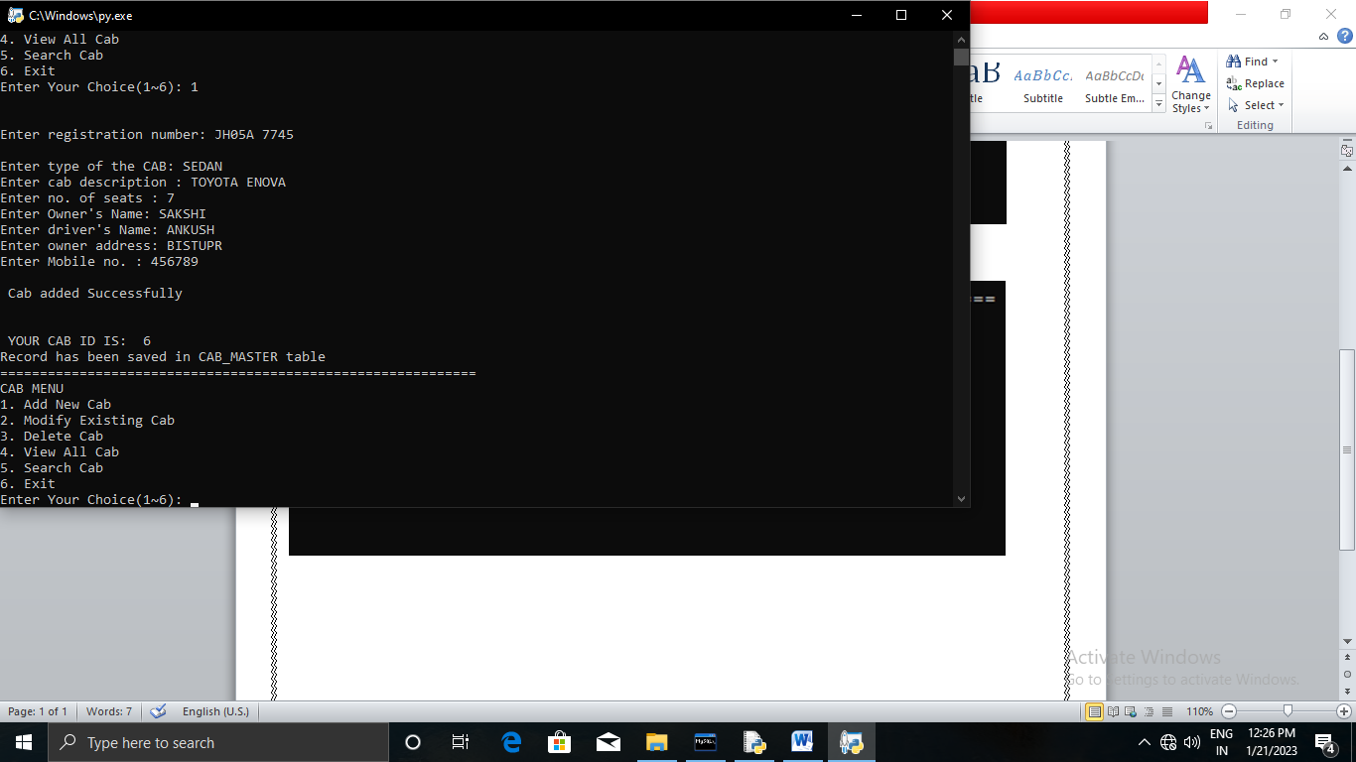

OUTPUT SCREEN 4
(MODIFY CAB DETAILS)
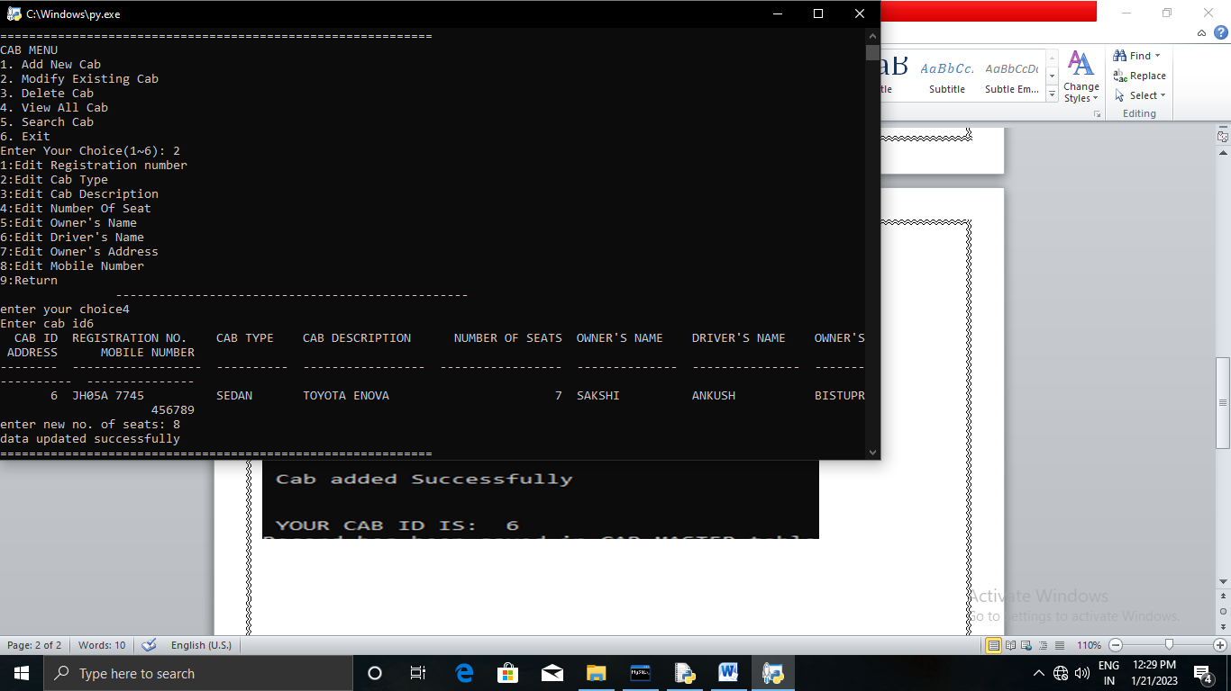

OUTPUT SCREEN 5
(VIEW ALL CAB DETAILS)
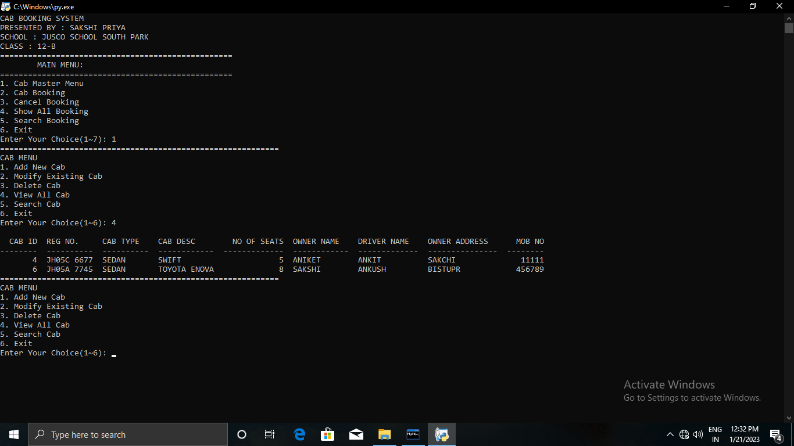

OUTPUT SCREEN 6
(SEARCH CAB DETAILS)

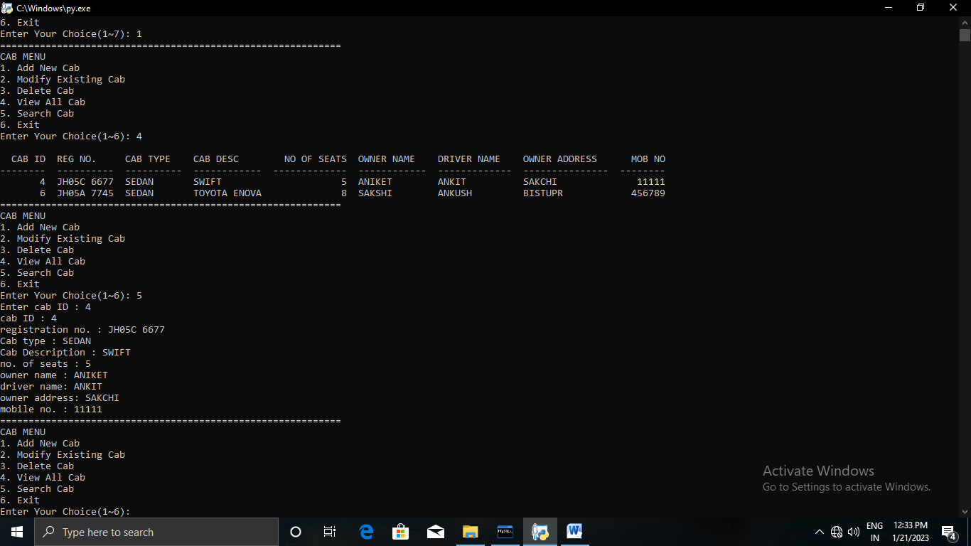
OUTPUT SCREEN 7
(CAB BOOKING)
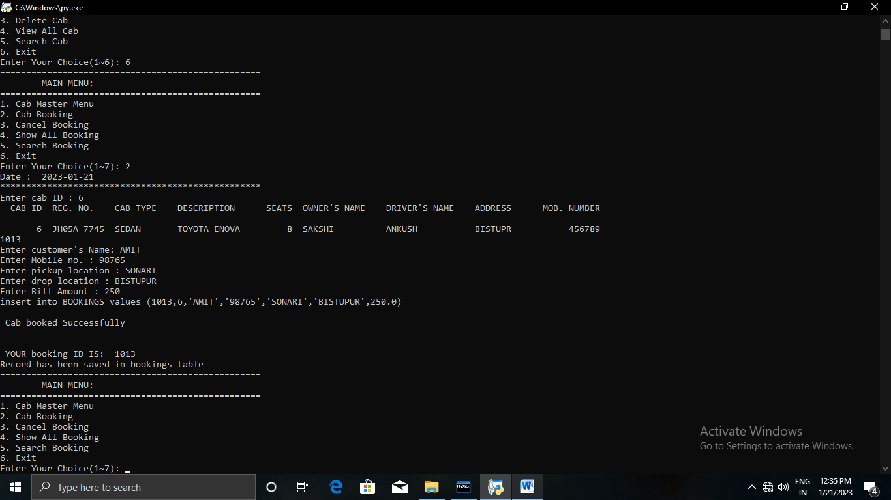

OUTPUT SCREEN 8
(SHOW ALL BOOKINGS)
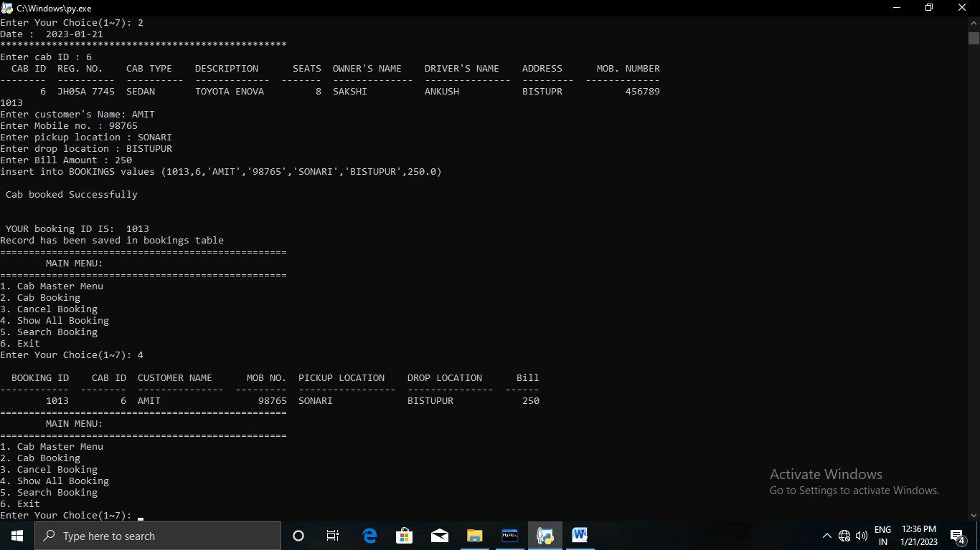

OUTPUT SCREEN 9
(SEARCH BOOKING)
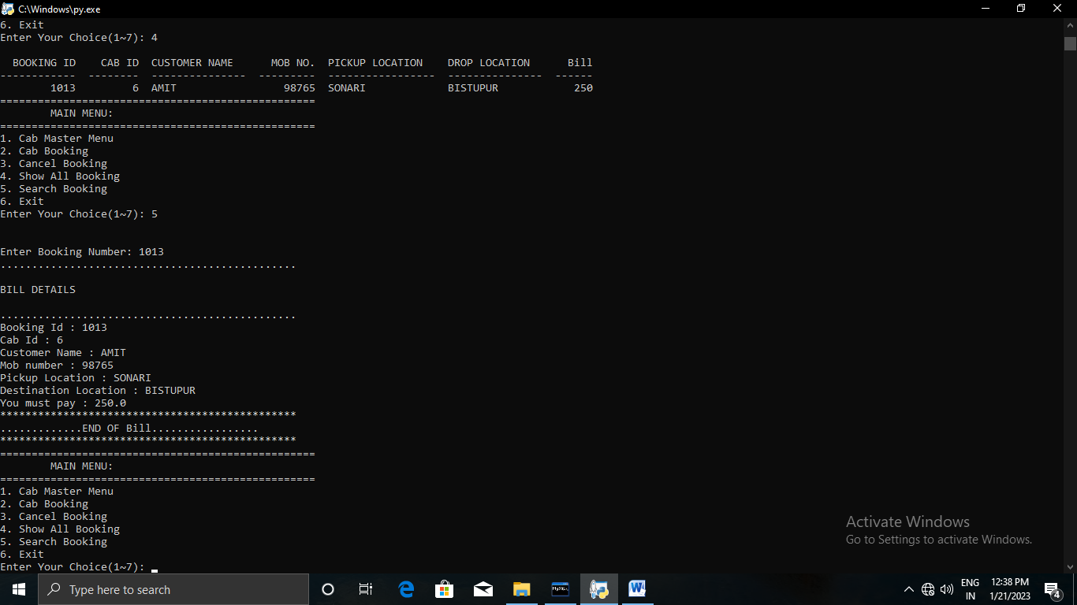

OUTPUT SCREEN 10
(DELETE CAB)
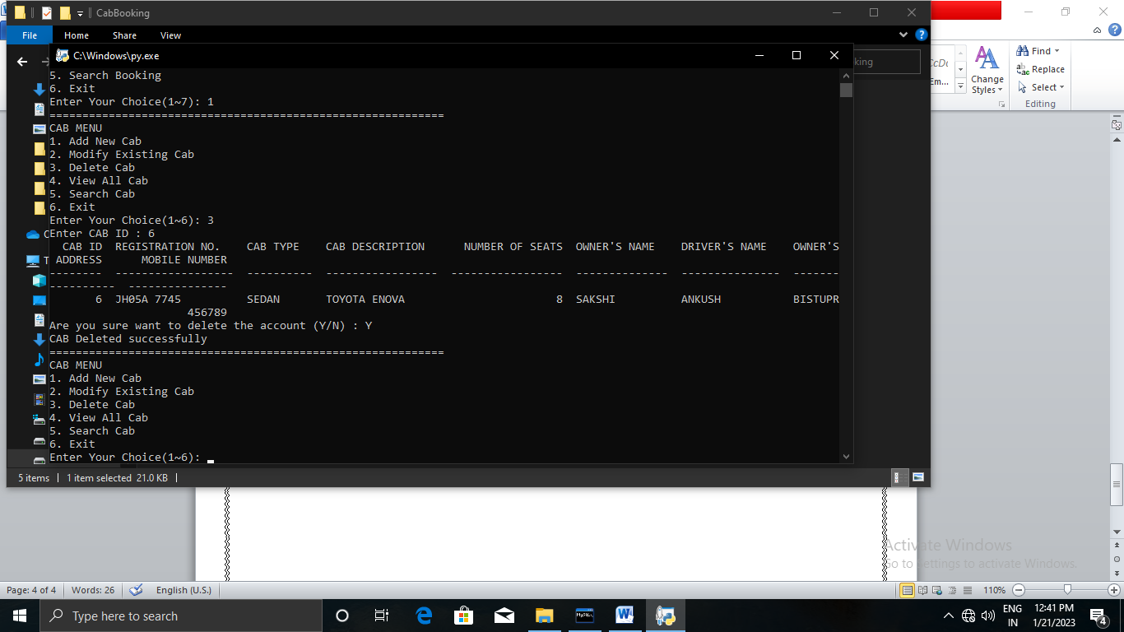
CONCLUSION
At the end of the project, I hereby conclude that it takes a lot of attention and patience to construct codes for a Cab Reservation System.
Also, I got to learn many new things about Python.

HaRdware and software Requirements

Hardware
❖Intel I5 processor.
❖Ram 4 GB
❖Hard Disk 1 Tb
❖Pen Drive
❖Compact Disc.
❖Printer to print the project report.

Software
❖Operating System Windows 8.1
❖Python 3.8 For Execution Of Program
❖MS Word For Report Presentation.

BIBLIOGRAPHY

*Computer science with Python - written by Dharmendra Singh
*Python programming a modular approach.by –Subham Sinha.
*Python programming a modular approach- Pooja Kumari
*Python programing a module approach – Rounak Gupta
*www.projectnotes.org
*www.w3schools.com
*www.programiz.com

THANKS!



